Current approach
- Take only single file commits (after removing all readmes, changelogs etc)
Create an even distribution
- Take 60 (CWE-79), 30 (CWE-89), 10 (CWE-22) * 2 -> for buggy and not buggy
- Take up to 16’000 -> 10 bins with even size (6, 3, 1)
- With possibility to have same file as buggy or not buggy (no ID check for that)
- Issue: some bins cannot be filled fully with the given files
  - So we just take what?? -> at least we should take them evenly distributed -> if buggy is from bin 10 then not_buggy also from bin 10?
Analysis
- Current setup – we have too much in lower bin (issue) -> because of the lack in some bins
- 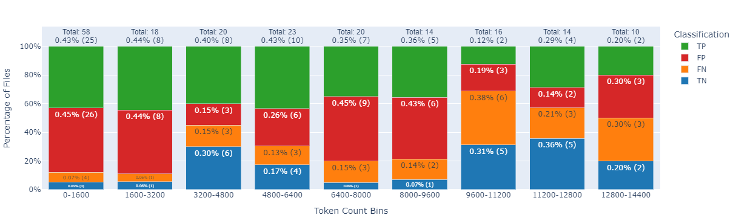

Overall results – recall and accuracy are around 50%
Recall 70 – 80 but still not that strong

2 files/bin 79 only

Do an visualization for the experiment (single file commits) -> CWE 79 (and others)

43 per bin (to be able to run some tests??) -> 0 – 4000

ALL positives/negative are just by simple regrex (‘there is no bug in string” and similar)

Prompt 1:
prompt = '''Look at the file content below and identify any bug of type {cwe_type}, then explain why it's a bug.

Expected Output:
BL: Bug lines (e.g., 170-172, 188)
EX: Explanation (e.g., In these lines the following issue is present)

File Content:
{file_content}
'''
CWE ID: CWE-79
Number of Samples: 313 Not from smallest to highest
Recall: 0.79
Precision: 0.52
Accuracy: 0.51
F1 Score: 0.63 (again some larger files are included)

Prompt 2:
prompt = '''Look precisely at the file content below. Analyze properly the content and tell me if there's any bug of type {cwe_type}. If there is no bug, output -1 as bug line, otherwise mention all lines that contain this bug. Also, provide a brief explanation of the bug in a given context.

Expected Output:
BL: Bug Lines (e.g., -1 or [170-172, 180] or 321-123 )
EX: Explanation (e.g., "No bug found" or "In these lines the such an issue is present because...")

File Content:
{file_content}
Number of Samples: 540
Recall: 0.77
Precision: 0.51
Accuracy: 0.52

F1 Score: 0.62 For all files!! (large N)

Prompt 3
prompt = '''Analyze the following file content for any instances of CWE type bugs specified by {cwe_type}. If no bugs are found, indicate this by listing '-1' under Bug Lines. Otherwise, list the lines that contain the specified bug and provide a brief yet comprehensive explanation.

Note:
- Line numbers should start from 1. For multi-line issues, indicate the range (e.g., [170-172]).
- Aim for explanations that are concise but detailed enough to clearly identify the issue.

File Content:
{file_content}

Expected Response Format:
- Bug Lines: [Insert your response here, e.g., '-1' or '[170-172, 180]' or '321-123']
- Explanation: [Insert your response here, e.g., "No bug found" or "The specified lines contain an issue because..."]'''
CWE ID: CWE-79
Number of Samples: 322
Recall: 0.28
Precision: 0.51
Accuracy: 0.51

F1 Score: 0.36

Prompt 4
prompt = '''Analyze the following file content for any instances of CWE type bugs specified by {cwe_type}. If no bugs are found, indicate this by listing '-1' under Bug Lines. Otherwise, list the lines that contain the specified bug and provide a brief yet comprehensive explanation.
Additionally attach score how much you are sure about your answer. 0-100

Note:
- Respond with lines that are provided in the file content. Line numbers should start from 1. For multi-line issues, indicate the range (e.g., [170-172]).
- Aim for explanations that are concise but detailed enough to clearly identify the issue.

Expected Response Format:
- Bug Lines: [Insert your response here, e.g., '-1' or '[170-172, 180]' or '321-123']
- Explanation: [Insert your response here, e.g., "No bug found" or "The specified lines contain an issue because..."]
- Score: [Insert your response here, e.g., "100" or "50" or "0"]

File Content:
{file_content}
'''
CWE ID: CWE-79
Number of Samples: 291
Recall: 0.53
Precision: 0.50
Accuracy: 0.50
F1 Score: 0.52

Prompt 5
prompt = '''Look precisely at the file content below. This file is part of a github repository {github_repo}. Analyze properly the content and tell me if there's any bug of type {cwe_type}. If there is no bug, output -1 as bug line, otherwise mention all lines that contain this bug. Also, provide a brief explanation of the bug in a given context. Additionally, provide a confidence score for your analysis.

Expected Output:
BL: Bug Lines (e.g., -1 or [170-172, 180] or 321-123 )
EX: Explanation (e.g., "No bug found" or "In these lines the such an issue is present because...")
CS: Confidence score: 0 - 100

File Content:
{file_content}
'''
CWE ID: CWE-79
Number of Samples: 306
Recall: 0.60
Precision: 0.50
Accuracy: 0.50

F1 Score: 0.54

Prompt 6
prompt = ''' Look at the file content below and identify any bug of type CWE-79, then explain why it's a bug.

What is CWE-79?
CWE-79, known as Cross-site Scripting (XSS), is a vulnerability that occurs when an application includes untrusted data in a webpage without proper validation or escaping, allowing attackers to inject malicious scripts. It manifests in three forms—stored, reflected, and DOM-based XSS—with consequences ranging from minor nuisances to severe security breaches, such as theft of sensitive information. Mitigation strategies include rigorous input validation and sanitization, secure coding practices, and implementing Content Security Policy (CSP) headers to restrict executable content to trusted sources.

Expected Output:
BL: Bug lines (e.g., 170-172, 188)
EX: Explanation (e.g., In these lines the following issue is present)

File Content:
'''

CWE ID: CWE-79
Number of Samples: 294
Recall: 0.49
Precision: 0.48
Accuracy: 0.48

F1 Score: 0.48

Prompt 7
prompt = '''Look at the file content below and identify any bug of type {cwe_type}, then explain why it's a bug. Add confidence score which tells, how much you are confident you are with your decision.

What is CWE-79?
CWE-79, known as Cross-site Scripting (XSS), is a vulnerability that occurs when an application includes untrusted data in a webpage without proper validation or escaping, allowing attackers to inject malicious scripts. It manifests in three forms—stored, reflected, and DOM-based XSS—with consequences ranging from minor nuisances to severe security breaches, such as theft of sensitive information. Mitigation strategies include rigorous input validation and sanitization, secure coding practices, and implementing Content Security Policy (CSP) headers to restrict executable content to trusted sources.

How to search for a bug connected to CWE-79?
1. Look for suspicious input validation or escaping mechanisms.
2. Check for the presence of untrusted data in the webpage.
3. Identify any JavaScript code that could be injected through the vulnerability.

How to calculate confidence score?
Add a percentage of the confidence score, this is based in your knowledge of the given repository, the context and if bug is clear or rather needs to be interpreted in a context.
If you are not sure about the bug, you can add a lower confidence score.

Expected Output:
BL: Bug lines (e.g., 170-172, 188)
EX: Explanation (e.g., In these lines the following issue is present)
CS: Confidence Score (e.g., 80%)

File Content:
{file_content}
'''

CWE ID: CWE-79
Number of Samples: 271
Recall: 0.57
Precision: 0.50
Accuracy: 0.50

F1 Score: 0.54

Prompt 8
prompt = '''Look precisely at the file content below. This file is from github repository {github_repo}. Analyze properly the content and tell me if there's any bug of type {cwe_type} (Improper Neutralization of Input During Web Page Generation ('Cross-site Scripting')). If there is no bug, output -1 as bug line, otherwise mention all lines that contain this bug. Also, provide a brief explanation of the bug in a given context.

Expected Output:
BL: Bug Lines (e.g., -1 or [170-172, 180] or 321-123 )
EX: Explanation (e.g., "No bug found" or "In these lines the such an issue is present because...")

File Content:
{file_content}
'''
CWE ID: CWE-79
Number of Samples: 294
Recall: 0.54
Precision: 0.48
Accuracy: 0.48

F1 Score: 0.51

